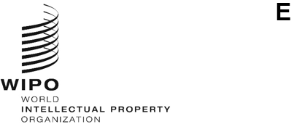
SCCR/46/1 PROV.
ORIGINAL: ENGLISH
DATE: JANUARY 15, 2025
Standing Committee on Copyright and Related Rights
Forty-Sixth Session
Geneva, April 7 to 11, 2025
DRAFT AGENDA
prepared by the Secretariat
- Opening of the session

- Adoption of the agenda of the forty-sixth session

- Accreditation of new non-governmental organizations

- Protection of broadcasting organizations

- Limitations and exceptions for libraries and archives

- Limitations and exceptions for educational and research institutions and for persons with other disabilities

- Other matters

- Proposal for Analysis of Copyright Related to the Digital Environment

Information Session on the Opportunities and Challenges Raised by Generative AI as it Relates to Copyright

- Proposal from Senegal and Congo to include the Resale Right (droit de suite) in the Agenda of Future Work by the Standing Committee on Copyright and Related Rights of the World Intellectual Property Organization

- Proposal on the Part of the Russian Federation With Regard to Strengthening the Protection of Theatre Directors’ Rights at the International Level

- Proposal for a Study Focused on the Public Lending Right in the Agenda and Future Work of the Standing Committee on Copyright and Related Rights of the World Intellectual Property Organization (WIPO)

- Proposal for a Study on the Rights of Audiovisual Authors and their Remuneration for the Exploitation of their Works

- Any other matters

- Closing of the session

[End of document]

