
SCCR/46/6
ORIGINAL: E
DATE: April 10, 2025
Standing Committee on Copyright and Related Rights
Forty-Sixth Session
Geneva, April 7 to 11, 2025
Information Session on Copyright and Generative Artificial Intelligence – Speaker Profiles
compiled by the Secretariat

 | Marcos Alves de Souza  Marcos Alves de Souza holds a master’s degree in Anthropology from the University of Brasília and is a career civil servant at the Ministry of Management and Innovation in Public Services. He headed the copyright department of the Ministry of Culture from 2004 to 2016. Between 2018 and 2022, he was advisor of cultural issues to the leadership of the Workers' Party in the Senate, when he participated in the drafting of legislation. He is currently the Secretary of Copyright and Intellectual Rights at the Ministry of Culture.
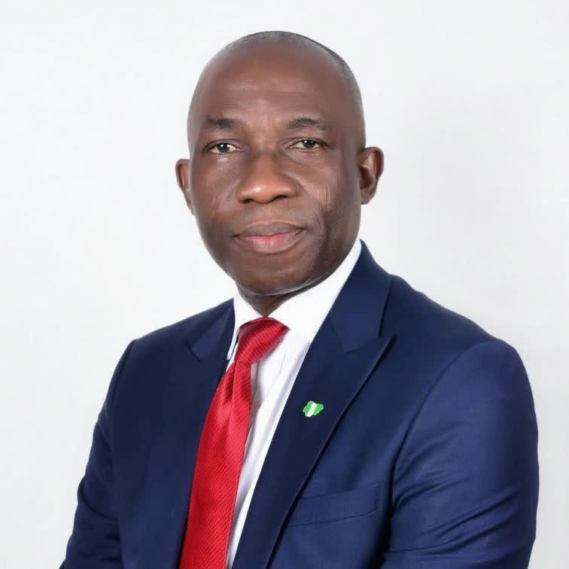 | John Asein  Dr. John Asein is a lawyer, copyright administrator and author with a wide range of experience in intellectual property law and policy. He has actively contributed to regional and international norm setting and played a key role in shaping copyright legislation in many African countries. As Director-General of the Nigerian Copyright Commission, he was instrumental in the enactment of the country’s Copyright Act, 2022, reinforcing copyright protection and its role in economic development.
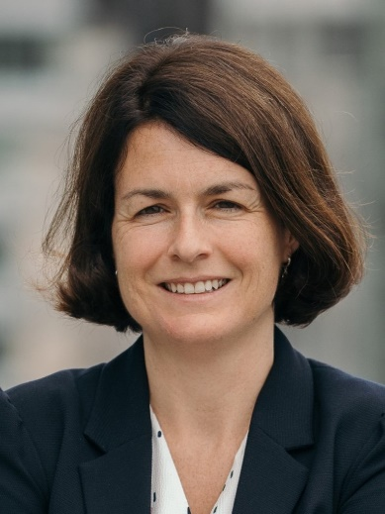 | Emmanuelle Du Chalard  Emmanuelle Du Chalard works in the European Commission as Head of the Copyright Unit in the Directorate General for Communications Networks, Content and Technology (DG CONNECT, Media Policy directorate). She joined the Commission in 2010 and has been working on EU copyright policy and legislation since 2014. She is actively involved in the discussions on AI and copyright at EU level. Emmanuelle holds a Master’s degree from the Paris Institute of Political Sciences.
 | Arun Chaturvedi  Arun Chaturvedi is an award-winning Canadian songwriter, producer and multi-instrumentalist, equally at home in the studio or on stage. Known for his ability to craft compelling music across genres, he has collaborated with legends such as Lamont Dozier and Felix Cavaliere (The Rascals) while writing and producing for both independent and major record labels and music publishers. His work extends to film, television and advertising, with credits on hit shows like Keeping Up With the Kardashians, General Hospital and many others.  Beyond his creative pursuits, Arun is a dedicated advocate for music creators. As President of the Songwriters Association of
Canada—one of the nation’s leading music creator advocacy groups—he champions the rights of songwriters and composers, working to build a more equitable and sustainable music industry.
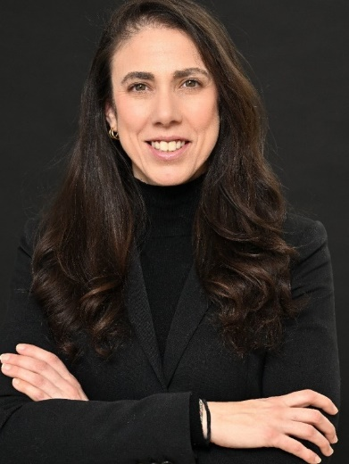 | Anna Dickson  Anna Dickson is Vice President of Content Strategy & Operations at Shutterstock, where she leads a global team driving content innovation across the company. A recognized expert in multimedia strategy, Anna focuses on how we create, organize and use visual and audio content to communicate in a rapidly evolving digital world. Before joining Shutterstock, she was a group product manager at Google, shaping the roadmap for the Licensed Media Service and integrating standards like IPTC and C2PA to Google’s generative experiences. Her career spans leadership roles in both tech and traditional media, including The Huffington Post and The Wall Street Journal.
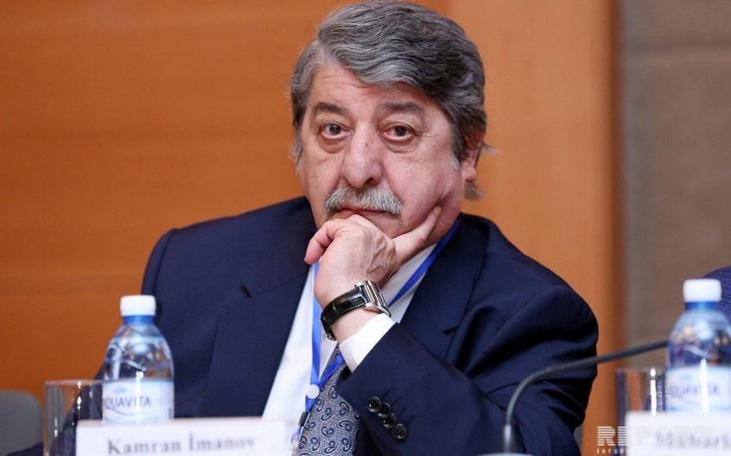 | Kamran Imanov  Mr. Kamran Imanov Chairman of the Board of the Intellectual Property Agency of the Republic of Azerbaijan. In order to form and develop the intellectual property system in Azerbaijan, he managed the preparation of more than 40 projects, including those related to regulations on the protection of intangible cultural heritage, digital rights management, e-commerce, commercialization and technology transfer, as well as the protection and enforcement of intellectual property rights. Mr. Imanov is an honorable professor at the Azerbaijan University of Architecture and Construction and delivered reports at international conferences held in Turkey, Germany, Hungary, USA, Switzerland, France and other countries. He is
the author of more than 110 scientific works on intellectual property and copyright. Under his scientific supervision a large number of Ph.D. and master’s degrees have been prepared.
 | Mary Critharis  Mary Critharis is the Acting Chief Policy Officer and Acting Director for International Affairs at the United States Patent and Trademark Office (USPTO). In this position, she serves as a policy advisor to the Under Secretary of Commerce for Intellectual Property and Director of the USPTO and Deputy Under Secretary of Commerce for IP and Deputy Director of the USPTO. She oversees the USPTO’s domestic and international policy matters related to intellectual property (IP) protection and enforcement on IP-related trade issues, including proposed legislation and international activities of the U.S. She also oversees the Office of Policy and International Affairs’ (OPIA) education and training programs through the

Global Intellectual Property Academy (GIPA), global advocacy initiatives through the IP Attaché Program and economic analyses through the Office of the Chief Economist, among her many duties.
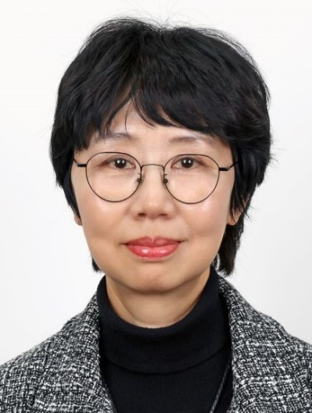 | Hyang-Mi Jung  Ms. Hyang-Mi Jung is the Director General of the Copyright Bureau of the Ministry of Culture, Sports and Tourism (MCST) and is a member of the Korean Government’s Senior Executive Service (SES). In that position, she oversees the Republic of Korea’s domestic and international copyright policy and legislative engagement concerning the Copyright Law. She joined the civil service in 1997 as MCST Deputy Director. Ms. Jung has spent nearly three decades in government roles in culture, arts and tourism policy including as Director for Arts Policy, Director for Tourism Policy, and Director for Publication Industry. In 2022, Ms. Jung was appointed as Director General of the MCST’s Regional Culture Policy Bureau. Afterwards,
she served as Director General of Culture Policy Bureau from August 2022 until she assumed her current position on January 22, 2024. Ms. Jung received her B.A. in Psychology from Yonsei University, Seoul, and completed her Ph.D. program in Law at the University Manchester, United Kingdom. She is native in Korean and proficient in English.
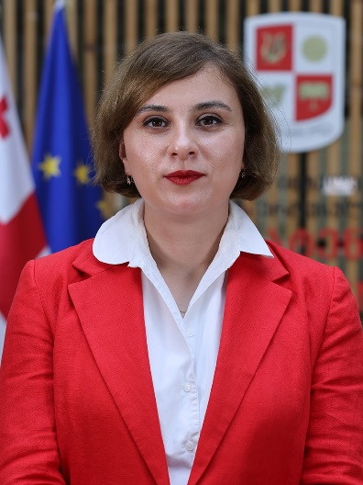 | Mery Macharashvili  Ms. Mery Macharashvili is a legal professional with over 15 years of experience in intellectual property (IP) and public law. She currently leads the Invention, New Varieties, and Breeds Department at the National Intellectual Property Center of Georgia (Sakpatenti).  Ms. Macharashvili previously managed the Trademarks, Geographical Indications and Design Department, where she played an important role in the development and enhancement of the geographical indications (GI) system, contributing to its establishment and refinement to meet both national and international standards. Additionally, she was instrumental in
the protection of GIs, ensuring that the system provided robust safeguards for geographical indications at both the national and international levels. She was in charge of administering the deposition system for works protected by copyright. Her career also includes roles at the Ministry of Finance of Georgia and the Public Service Development Agency operating under the Ministry of Justice of Georgia.
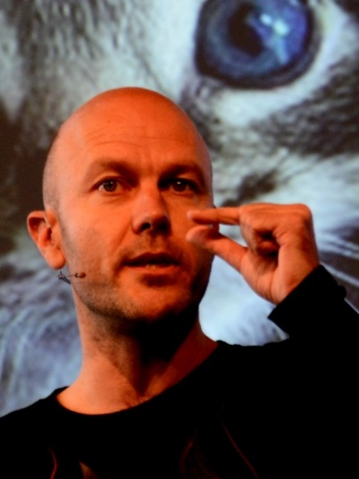 | Cédric Manara  Cédric Manara, Ph.D., has lost his hair teaching, writing or consulting. He has been a full-time law professor at EDHEC Business School (France) and held visitorships in Finland, Italy, Japan and the USA, published a lot on intellectual property and internet legal issues and also was a consultant for e-commerce companies or law firms. Cédric joined Google in 2013, where he is a Director and leads the Global Copyright Legal team.
 | Graciela Melo Sarmiento  Lawyer, specialized in Commercial Law at the University of Los Andes and in Telecommunications Regulation and New Technologies at the Externado University, expert in Intellectual Property, Japan International Cooperation Agency Fellow, Ph.D. student at the Austral University. University professor and tutor at the WIPO Academy. Independent advisor and consultant, listed in the Chambers & Partners ranking for Intellectual Property since 2013. Arbitrator for the Bogotá Chamber of Commerce. Former president of the Colombian Copyright Center CECOLDA and member of International Literary and Artistic Association (ALAI).
 | Péter Mezei  Péter Mezei is a professor of law at the University of Szeged (Hungary). He was awarded an honorary adjunct professorship (dosentti) at the Faculty of Law, University of Turku (Finland) in December 2014. He is a chief researcher at Vytautas Magnus University (Lithuania) and a professor invité at the Université Jean Moulin Lyon III (France). He coordinates the Comparative Intellectual Property Law LLM of the University of Szeged, and the joint IP LLM of the Technical University of Dresden and University of Szeged on the Szeged side. His courses and research focus on comparative law, as well as comparative, digital, International and European copyright law. He is a member of the European Copyright Society and the Hungarian

Copyright Expert Board. He is the Copyright Vice President of the Hungarian IP Association. His key English articles are available via SSRN at https://papers.ssrn.com/sol3/cf_dev/‌AbsByAuth.cfm?per_id=1697918. ORCID number: https://orcid.org/0000-0003-4832-2079.
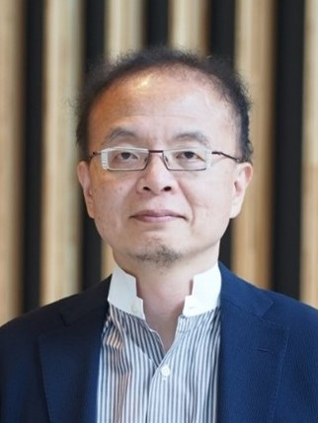 | Hirohiko Nakahara  Hirohiko Nakahara has served as a Director-General of the Agency for Cultural Affairs since July 2021. Recently, he has been leading the team responsible for amending the Japanese Copyright Act in May 2023, as well as the discussion on generative AI and copyright issues in Japan.  Mr. Nakahara has devoted himself to the field of intellectual property, as well as economic and industrial policy, through more than 30 years of combined experience at the Ministry of Economy, Trade and Industry (METI), the Ministry of Finance, the Ministry of Justice and the Cabinet Secretariat. He has been engaged in the revisions of various related laws such as
the Companies Act and the Unfair Competition Prevention Act as well as in government growth strategies such as the Regulatory Reform Implementation Plan and the Future Investment Strategy. He has established the Japanese regulatory sandbox system. In 2020, he was selected as one of The World’s 50 Most Influential People Revolutionizing Government in the Agile 50 list, which is a joint initiative by Apolitical and the World Economic Forum Global Future Council on Agile Governance.

After graduating from the University of Tokyo (Bachelor of Law) in 1991, he joined the Ministry of Economy, Trade and Industry. He also studied at Cornell University (Ph.D. candidate).
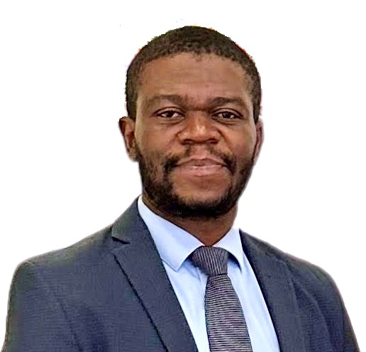 | François Joseph Nnemete Beyeme  François Joseph Nnemete Beyeme is an expert in telecommunications policy and regulation. He currently serves as the Director of Telecommunications and ICT Regulation at Cameroon’s Ministry of Posts and Telecommunications. With a strong international background and academic training, he holds a professional master’s degree in Economics from the University of Rennes 1 (France), as well as a professional master’s in Telecommunications Management in the Age of Convergence from the UK Telecommunications Academy. Mr. Nnemete Beyeme has also earned several certifications from global institutions, including the United States Telecommunications Training Institute (USTTI), the American

University Washington College of Law (AUWCL) and the Fletcher School at Tufts University. These certifications cover key areas such as telecommunications regulatory policy, digital currency and 5G technology. His expertise spans telecommunications and ICT policy and regulation, digital transformation support for organizations and the promotion of youth digital entrepreneurship. In addition to his public sector role, he is a business and management consultant, with proven competence in engineering, strategic planning, performance optimization, policy and regulatory framework development.
 | Thibault Roucou  Thibault Roucou is Deezer’s Royalties and Reporting Director. In this capacity, he leads the management and continuous improvement of the company’s royalty distribution channels, ensuring that rights owners around the world—from artists and producers to publishers—are accurately compensated. Thibault was hired back in 2013 as a data engineer, when he was tasked with building the company’s internal royalty calculation software. Thibault’s journey at Deezer reflects a combination of technical expertise and a commitment to supporting the creative economy.
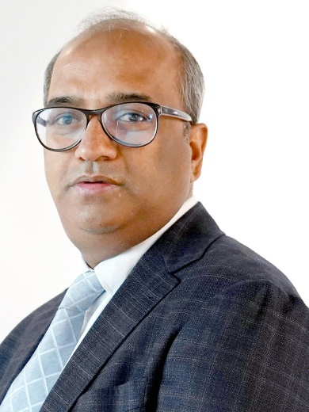 | Abhishek Singh  Abhishek Singh is a career civil servant with 30 years of experience of governance and policy formulation, specializing in the use of technology for improving governance. He is presently posted as Additional Secretary, Ministry of Electronics and Information Technology (MeitY), Government of India, with responsibilities for artificial intelligence and emerging technologies; R&D in electronics and IT; and convergence, communications and broadband technologies (CC&BT). He previously served as the CEO of the Department of Personnel and Training’s National Program for Civil Services Capacity Building (Karmayogi Bharat) and, at MeitY, as the CEO of the National eGovernance Division, the Digital India Corporation

and the MyGov platform. He has completed a master’s degree in public administration from Harvard Kennedy School of Government and is an alumnus of IIT Kanpur.
 | Anastasia Stasenko  Dr. Anastasia Stasenko is co-founder of French startup pleias. Pleias’ mission is to design energy-efficient language models (LLMs) for information-intensive and highly regulated industries, using exclusively contents with permissive licences for training. Among her recent projects is the development of Albert, the first generative AI model assisting French civil servants in responding to citizen requests, in collaboration with Étalab. In addition to her role at pleias, she holds the position of Associate Lecturer at Sorbonne-Nouvelle in Data Analysis and Digital Communications.
 | Qian Wang  Wang Qian is a professor of law and the Vice Chairman of the Academic Committee in East China University of Political Science and Law. He also serves as the Vice Chairman of the China Copyright Association. He received his LL.M from the University of Toronto in Canada and his Ph.D. from Peking University. He published the book Study on Exclusive Rights of Copyright in the Network Environment, Protection and Regulation of Technological Measures in the Copyright Law, and Copyright Protection on the Internet. His textbook Intellectual Property Law Course (1-8 editions) is one of the most popular IP textbooks in China. Mr. Wang acts as a consulting expert for many courts and procuratorates, including
the Beijing Higher People’s Court, Shanghai People’s Procuratorate and Shanghai Intellectual Property Court. He participated in the drafting of the Regulations on the Protection of Information Network Transmission Rights and is a member of the Expert Committee for the third revision of the Copyright Law. He was honored as one of the Top Ten Outstanding Young Jurists in the Ninth National Awards.

[End of document]

