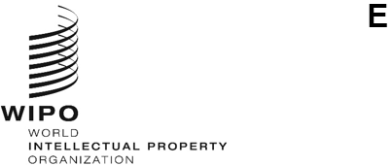
WO/GA/58/1
ORIGINAL: ENGLISH
DATE: April 7, 2025
WIPO General Assembly
Fifty-Eighth (27th Ordinary) Session
Geneva, July 8 to 17, 2025
COMPOSITION OF THE PROGRAM AND BUDGET COMMITTEE
Document prepared by the Secretariat
The members of the WIPO Program and Budget Committee (PBC) are elected for a period of two years.
At its meeting in July 2023, the WIPO General Assembly unanimously elected the following States as members of the PBC: Algeria, Argentina, Belarus, Brazil, Canada, Chile (2025), China, Colombia, Czech Republic, Ecuador (2024), Egypt, El Salvador, Estonia, France, Germany, Ghana, Guatemala, India, Indonesia (2025), Iran (Islamic Republic of) (2024), Italy, Japan, Kenya, Kyrgyzstan, Lithuania, Mexico, Morocco, Namibia, Nigeria, Pakistan, Panama, Peru, Poland, Portugal, Qatar, Republic of Korea, Republic of Moldova, Romania, Russian Federation, Saudi Arabia, Singapore (2025), Slovakia, South Africa, Spain, Sweden, Switzerland (ex officio), Tajikistan, Tunisia, Türkiye, Uganda, United Arab Emirates, United Kingdom, United States of America, Uzbekistan, Viet Nam (2024), Yemen (53).

As the mandate of the current members of the PBC expires at the close of the present ordinary session of the WIPO General Assembly, new members must be elected by the WIPO General Assembly for the period starting from the close of the present session to the close of the next ordinary session of the WIPO General Assembly in July 2027.
The WIPO General Assembly is invited to decide on the membership of the Program and Budget Committee for the period as provided in paragraph 3 of document WO/GA/58/1.
[End of document]

