English Language
The upward curving lines of the World Intellectual Property Organization’s logo evoke human progress driven by innovation and creativity.

WO/GA/58/3

ORIGINAL: ENglish

DATE: april 24, 2025

**WIPO General Assembly**

**Fifty-Eighth Session**

**Geneva, July 8 to 17, 2025**

Annual Report by the Director of the Internal Oversight Division (IOD)

*prepared by the Secretariat*

1. The present document contains the “Annual Report by the Director of the Internal Oversight Division (IOD)” (document WO/PBC/39/5), submitted to the WIPO Program and Budget Committee (PBC) at its Thirty-Ninth Session (June 16 to June 20, 2025).
2. Any decisions of the PBC regarding that document will appear in the “List of Decisions adopted by the Program and Budget Committee” (document WO/GA/58/3).

[Document WO/PBC/39/5 follows]

|  |  |  |
| --- | --- | --- |
|  | The upward curving lines of the World Intellectual Property Organization’s logo evoke human progress driven by innovation and creativity. | **E** |
| WO/PBC/39/5 | | |
| ORIGINAL: english | | |
| **DATE: april 24, 2025** | | |

**Program and Budget Committee**

**Thirty-Ninth Session**

**Geneva, June 16 to 20, 2025**

ANNUAL REPORT BY THE DIRECTOR OF THE INTERNAL OVERSIGHT DIVISION (IOD)

*prepared by the Secretariat*

1. In accordance with paragraph 51 of the Internal Oversight Charter (IOC), the Director, Internal Oversight Division (IOD), shall submit, annually, a summary report to the World Intellectual Property Organization (WIPO) General Assembly, through the Program and Budget Committee (PBC). The report shall give an overview of the internal oversight activities conducted during the reporting period from January 1, 2024, to December 31, 2024.
2. The following decision paragraph is proposed.
3. *The Program and Budget Committee (PBC) recommended to the WIPO General Assembly to take note of the “Annual Report by the Director of the Internal Oversight Division (IOD)” (document WO/PBC/39/5).*

[Annual Report by Director, IOD follows]

**ANNUAL REPORT BY THE DIRECTOR OF THE INTERNAL OVERSIGHT DIVISION**

January 1, 2024 to December 31, 2024

**TABLE OF CONTENTS**

LIST OF ACRONYMS 3

EXECUTIVE SUMMARY 4

BACKGROUND 5

SOME HIGHLIGHTS OF 2024 5

PLANNING PRINCIPLES 6

PROFESSIONAL STANDARDS 6

ENGAGEMENTS WITH HIGH-PRIORITY OVERSIGHT RECOMMENDATIONS 6

ENGAGEMENTS STARTED IN 2023 AND REPORTED IN 2024 6

REPORTED ENGAGEMENTS IN 2024 8

INVESTIGATIVE ACTIVITIES 11

INSTANCES WHERE INFORMATION OR ASSISTANCE WAS REFUSED 15

STATUS OF IMPLEMENTATION OF OVERSIGHT RECOMMENDATIONS 15

COOPERATION WITH EXTERNAL OVERSIGHT BODIES 18

OTHER OVERSIGHT WORK 18

IOD QUALITY ASSURANCE AND IMPROVEMENT PROGRAM 20

INTERNAL OVERSIGHT RESOURCES 22

2025 AND BEYOND 23

CONCLUSION 24

ANNEX – List of IOD Documents and reports

# LIST OF ACRONYMS

| **AFMS** | Administration, Finance, and Management Sector |
| --- | --- |
| **AMC** | WIPO’s Arbitration and Mediation Center |
| **ASHI** | After-Service Health Insurance |
| **ECCM** | Enterprise Collaboration & Content Management |
| **GIAS** | Global Internal Audit Standards |
| **HRMD** | Human Resources Management Department |
| **IAOC** | Independent Advisory Oversight Committee |
| **IOC** | Internal Oversight Charter |
| **IOD** | Internal Oversight Division |
| **IP** | Intellectual Property |
| **ISMS** | Information Security Management Systems |
| **IT** | Information Technology |
| **MIR** | Management Implication Report |
| **MTSP** | Medium-Term Strategic Plan |
| **PCT** | Patent Cooperation Treaty |
| **QAIP** | Quality Assurance and Improvement Program |
| **RAMP** | Reserve Advisory and Management Partnership |
| **RIAS** | Representatives of Internal Audit Services |
| **SMART** | Specific, Measurable, Achievable, Relevant, Time-bound |
| **UN** | United Nations |
| **UNHCR** | United Nations High Commissioner for Refugees |
| **UNEG** | United Nations Evaluation Group |
| **WEP** | Indigenous and Local Community Women Entrepreneurship Program |
| **WIPO** | World Intellectual Property Organization |

# EXECUTIVE SUMMARY

1. The year 2024 marked the third year of the Medium-Term Strategic Plan (MTSP) for 2022-2026. As part of its contribution to the Foundation of the Organization’s Strategy House, the Internal Oversight Division (IOD) conducted engagements and made recommendations aimed at, among other things, supporting the achievement of the Organization’s areas of strategic focus and assessing various elements of its control environment.
2. During the reporting period, IOD issued five internal audit reports, two validation reports, four evaluation reports, five pre-evaluation review reports, one advisory report, 18 investigation reports, and two Management Implication Reports (MIR).
3. There were no instances in which IOD’s access to records, personnel, and premises was restricted, nor were there any circumstances that could be considered threatening the operational independence of IOD.
4. IOD’s work focused on supporting the MTSP through relevant engagements such as the audit of Cybersecurity Management, audit of the Patent Cooperation Treaty (PCT) Translation Division, and audit of the WIPO Nigeria Office. It validated the After Service Health Insurance (ASHI) Claims Sample Data and undertook a pilot review of the Organizational Key Controls Design and Operating Effectiveness.
5. IOD performed pre-evaluation reviews of five programs to understand each program’s scope, structure, outcomes, and ongoing impact. The reviews assessed the retention of evaluative data and informed the assessment of the immediate need for full-scale evaluations.
6. As part of its advisory services, following its first review of Key Controls, IOD engaged in a consultative process with the Office of the Controller to refine control descriptions and consolidate overlapping ones.
7. IOD made 36 recommendations and closed 66 during the reporting period. As of the end of 2024, there were 30 open recommendations. Of these, 23 were related to IOD engagements, six were from reports by the External Auditor, and one was linked to a review by an external party.
8. In 2024, 16 investigation matters were carried forward from 2022 and 2023, with one further split in 2024 into six matters related to six subjects. Forty-five new complaints were registered. Sixty-six matters were addressed, 38 complaints were closed following preliminary evaluation, and 18 investigations were concluded. As of December 31, 2024, there were 10 pending matters, comprising six at the preliminary evaluation stage, three ongoing investigations, and one on hold. None of the matters were deemed to have a significant financial impact on the Organization.
9. After each engagement, IOD sought feedback from colleagues of organizational units that had been audited and/or evaluated and assessed its performance through client satisfaction surveys. At the end of 2024, the consolidated analysis of the post-engagement survey results indicated a satisfaction rate of 87 per cent and 85 per cent for surveys sent at least one year after completing engagements. Additional comments helped inform IOD’s Quality Assurance and Improvement Program (QAIP).
10. In 2025, IOD will continue to support the Foundation of the Organization’s Strategy House and the achievement of the MTSP by providing assurance, advice, learning, and support for accountability, internal justice, and integrity.

# BACKGROUND

1. The purpose of WIPO’s IOD is to provide independent and effective internal oversight for the Organization, in line with the Internal Oversight Charter (IOC) provisions.
2. The IOC requires[1] the Director, IOD, to submit, annually, a summary report to the WIPO General Assembly, through the Program and Budget Committee (Annual Report by the Director, IOD). The Annual Report shall give an overview of the internal oversight activities conducted during the reporting period, including the scope and objectives of such activities, the work undertaken, and the progress on the implementation of internal oversight recommendations.
3. In accordance with the IOC, the Director General and the Independent Advisory Oversight Committee (IAOC) were provided with a draft version of the Annual Report for their comments. Their feedback was considered when finalizing the report.

# SOME HIGHLIGHTS OF 2024

1. WIPO has a unique business model where most of its funding is drawn from fees. This requires a strong focus on efficiency and effectiveness to deliver expected results to Member States without seeking additional funding. Throughout 2024, IOD continued to contribute and support WIPO in further strengthening controls, accountability, transparency, and learning through audits, evaluations, investigations, and advisory[2] engagements.
2. In July 2024, the WIPO General Assembly approved the updated IOC as recommended by the Program and Budget Committee. Subsequently, the Audit and Investigation Policies and Manuals were reviewed and updated per the IOC. The updated Evaluation Policy and Manual are scheduled for completion in 2025.
3. IOD successfully addressed its 2024 oversight work plan, demonstrating a steadfast commitment to excellence and accountability. All internal audit and validation engagements were delivered per the annual plan. Likewise, all pre-evaluation engagements were successfully executed. Only one evaluation[3] was rescheduled for delivery in 2025, with desk reviews commenced in 2024.
4. Pilot Key Controls testing by IOD in 2024, followed by recommendations and a subsequent consultative process with the Office of the Controller, helped reformulate controls. These efforts rationalized the number of controls from 76 to 40, focusing on t Key Organizational Processes and Controls and thereby strengthening the internal controls framework at WIPO.
5. The combined efforts of IOD, the Office of the Controller, and respective WIPO Sectors reduced significantly the number of open recommendations as of December 31, 2024. In 2024, 66 oversight recommendations were closed. At year-end, there were 30 open recommendations, six of which were from the External Auditor.
6. Although no evaluations were performed in 2024, the pre-evaluation reviews of five programs resulted in IOD’s broader understanding of the programs’ activities. The reviews laid the groundwork for future thematic evaluations and immediately identified actionable steps to improve the program’s impact and future evaluability.
7. IOD strengthened its intake process while working with the Internal Justice System, including line management while protecting the rights of complainants as provided for within the Investigative Framework. As a result, several matters were referred to and satisfactorily addressed within the Organization without resulting in a formal investigation. The timeline to address matters registered in 2024 was reduced considerably to an average of under two months.
8. Looking ahead, IOD will continue its work on contributing to and supporting the MTSP’s ongoing implementation through relevant engagements in 2025.

# PLANNING PRINCIPLES

1. In developing its 2024 oversight work plan, IOD considered several factors, including risk ratings, relevance, horizon scanning, oversight cycle, and feedback from Management and Member States. As per paragraph 30(a) of the IOC, the IAOC reviewed and provided advice on the draft plan before it was finalized.
2. To provide effective oversight coverage while efficiently using limited resources and avoiding potential overlaps, IOD considered the work done by the External Auditor and other oversight bodies, such as the Joint Inspection Unit, and evaluations commissioned by the Committee on Development and Intellectual Property.

# PROFESSIONAL STANDARDS

1. IOD undertook its audit activities in conformance with the Global Internal Audit Standards (GIAS) issued by the Institute of Internal Auditors (IIA) on January 9, 2024, with earlier adoption thereof than the mandatory effective date of January 9, 2025.
2. The evaluation engagements and related activities were performed per the International Standards in Evaluation Practice set out by the United Nations Evaluation Group (UNEG).
3. The investigative work was conducted per the Uniform Principles and Guidelines for Investigations endorsed by the Conference of International Investigators (CII).

# ENGAGEMENTS WITH HIGH-PRIORITY OVERSIGHT RECOMMENDATIONS

1. During the reporting period, five engagements resulted in five high-priority recommendations agreed upon with Management and regularly followed up by IOD. These recommendations are highlighted under each relevant engagement in the following Sections of this report.

# ENGAGEMENTS STARTED in 2023 AND REPORTED in 2024

## Audit of CLOUD MANAGEMENT (IA 2023-02)

1. The audit was conducted between August and December 2023, and the report was issued on January 31, 2024. The overall engagement conclusion was “Satisfactory.” Details of the engagement were reported in the 2023 Annual Report by the Director, IOD.

## AUDIT AND EVALUATION OF PCT OPERATIONS AND CUSTOMER RELATIONS – PART II: VERIFICATION OF THE PCT CULTURE OF CUSTOMER SERVICE (EVAL 2022-05)

1. This engagement was carried forward from the 2022 oversight work plan. This was the second part of the combined engagement “Audit and Evaluation of PCT Operations and Customer Relations”. The first report, focusing on audit results, was released in April 2023[4]. Due to some constraints, the evaluation commenced in January 2023, with findings reported in May 2024.
2. The verification aimed to:
   1. Establish whether the culture of customer service is effectively implemented and aligned with the PCT’s related performance objectives, expected results, and relevant strategic Pillars of the Organization's MTSP; and
   2. Identify opportunities to enhance services and customer relations through adaptive learning and behavioral science.
3. The verification focused on the PCT Legal and International Affairs Department, which is responsible for strengthening the PCT’s role in the international patent system and supporting stakeholders.
4. IOD noted that the Department’s customer service activities align with WIPO's Strategic Goals and contribute to Strategic Pillars 3 and 4 of the MTSP. Although a documented customer service strategy had not been developed, the Department conducted biennial customer satisfaction surveys to foster a service culture.
5. IOD made six recommendations to, among other things, increase survey participation, enhance real-time client feedback methods, and share customer service best practices across WIPO.

## Impact evaluation of women entrepreneurs’ initiatives at WIPO – phase ii (eval 2023-02)

1. To facilitate WIPO's learning process, the Evaluation Section of IOD conducted a comprehensive mapping analysis between August 2022 and March 2023 (phase I). The analysis focused on 120 initiatives that WIPO had planned or implemented concerning women inventors and innovators between 2018 and 2022[5].
2. Based on the mapping analysis, three initiatives were selected for evaluation. The aim was to identify best practices that could be applied to future WIPO projects supporting women entrepreneurs in using intellectual property (IP) more effectively.
3. **The “Chobe Baskets” Project (Botswana):** The project was launched in 2019 to support basket producers in Kasane, Botswana, by branding their products using IP tools.
4. The evaluation, conducted between September and December 2023, with the final report issued in April 2024, identified increased empowerment among the project’s women participants but noted the opportunity for more youth engagement and better marketing and commercialization strategies by the cooperative union for Chobe baskets, leveraging as appropriate on available national government support or other international cooperating partners.
5. **The Indigenous and Local Community Women Entrepreneurship Program (WEP):** The engagement occurred between August and December 2023, with the final report issued in November 2024.
6. The WEP is a part of the Traditional Knowledge Division's Community Entrepreneurship Program, which aims to strengthen the capacity of women entrepreneurs from Indigenous Peoples and Local Communities to make strategic and effective use of IP tools. The Program consists of two phases: (i) the training phase (a practical workshop); and (ii) the mentoring and matchmaking phase.
7. The evaluation highlighted the success of the mentoring component, the importance of networking among program participants, and the significant benefits of in-person workshops.
8. **The Project on Increasing the Role of Women in Innovation and Entrepreneurship:** The engagement was conducted between November 2023 and February 2024.
9. Implemented by the IP for Business Division from 2019 to 2022 and funded by the WIPO Development Agenda, the project aimed to increase the involvement of women inventors and innovators in the national innovation system by helping them effectively use the IP system to protect and commercialize their inventions. The project provided support programs, mentorship access, and networking opportunities.
10. The evaluation emphasized the importance of engaging national focal points and the mentor-mentee approach. Additionally, it identified a significant demand for greater awareness and education on IP matters.
11. Following the evaluation of the three initiatives, the Evaluation Section of IOD provided recommendations focused on ensuring the sustainability of current and future projects, expanding mentor-mentee support, and improving the management of project participants’ expectations regarding WIPO’s support in branding and commercialization.

# REPORTED ENGAGEMENTS IN 2024

## Validation of the After-Service Health Insurance (ASHI) (IA 2024-01)

1. IOD validated a sample of ASHI claims data settled between November 2022 and October 2023, which the actuary used to calculate the ASHI liability for WIPO’s financial statements as of December 31, 2023.
2. IOD reviewed the internal controls of the ASHI provider and found no significant changes affecting ASHI claims processing. However, the ASHI provider’s European entities did not undergo SOC 2 assessments,[6] and ISO 9001:15 certification[7] reports were not shared with WIPO. No significant issues were found in WIPO’s ASHI management controls.
3. One recommendation, implemented in 2024, was to exclude medical expenses covered by other insurers from ASHI data reporting. The engagement was concluded as “Satisfactory, some improvements needed," primarily due to the insurance provider’s lack of preparation and submission to WIPO of SOC 2 assessments. IOD recommended that this provision be included in updated contract terms.

## Audit of CYBERSECURITY MANAGEMENT (IA 2024-02)

1. IOD engaged a professional services consulting firm to audit Cybersecurity Management at WIPO, assess the adequacy and effectiveness of governance, risk management, and controls, and identify enhancement opportunities.
2. The audit found that WIPO has implemented security measures aligned with ISO 27001 standards[8], and specific security measures are applied for the WIPO Cloud environment. One high-priority recommendation was made relating to the regular update of security patches. Based on the audit observations, the overall engagement conclusion was “Satisfactory, some improvements needed.”

## IOD Review of Key Controls Design and Operating Effectiveness at WIPO (IA 2024-03)

1. IOD piloted Key Controls testing at WIPO to provide Member States additional assurance over the key areas of governance, risk management, and controls and support the Director General’s Statement on Internal Control for the year ending December 31, 2025, following the External Auditor’s recommendation[9] and requirements of the new GIAS.
2. Between February and April 2024, 45 Key Controls were independently assessed by IOD. While no significant process flaws were identified, conclusions on the design, implementation, and effectiveness of Key Controls were deferred pending further control reformulation to focus on those that assure the operating effectiveness of the associated processes. Additionally, as proposed by IOD, there was a need to streamline the organizational Key Controls to remove any overlaps that address the same control objectives. The Governance, Risk and Compliance Section (formerly Office of the Controller) and other process owners have since reformulated and rationalized the Key Controls from 76 to 40. IOD’s 2025 work plan includes testing the key controls throughout 2025.

## Audit of the PCT Translation Division (IA 2024-04)

1. IOD audited the PCT Translation Division to evaluate the adequacy and effectiveness of governance, risk management and controls over key processes covering activities in 2023 and 2024. The audit assessed alignment with expected results, budget execution, resource management, performance monitoring, risk management, key risks and controls, translation quality control, information technology (IT) security of core applications,[10] cost-efficiency[11] of translations, sourcing of external translators, business continuity management, and related systems and tools.
2. The overall engagement conclusion was "Satisfactory, some improvements needed” based on the audit observations.

## Internal Audit of WIPO Nigeria Office (IA 2024-05)

1. The objective of the WIPO Nigeria Office audit was to evaluate the adequacy and effectiveness of governance, risk management and controls over key processes covering activities in 2024. The audit assessed alignment with expected results, budget execution, resource management, performance monitoring, risk management, key risks and controls, business continuity management, and related systems and tools.
2. The overall engagement conclusion was “Fully Satisfactory,” and IOD issued no formal recommendations.

## Validation of the WIPO Performance Report (VALID 2024-01)

1. IOD’s validation of the WIPO Performance Report 2022/23 was reported at the Thirty-Seventh Session of the Program and Budget Committee, Geneva, June 10 to 14, 2024[12] and the Sixty-Fifth Series of Meetings of the Assemblies of WIPO, July 9 to 17, 2024.

## PRE-Evaluation reviews

1. According to the 2024 oversight work plan, the Evaluation Section was to undertake evaluability assessments of specific programs to determine the need for and scope of full-scale evaluations as applicable. IOD did not have evaluation staff due to absences or sick leave from February to December 2024. Notwithstanding the aforementioned staffing limitations, IOD conducted pre-evaluation reviews of the following programs:
   1. WIPO Connect (EVAL 2024-01);
   2. Madrid Fellowship Program (EVAL 2024-02); and
   3. WIPO Academy IP eLearning Section (EVAL 2024-04).
2. During these reviews, and in consultation with Management, the pre-evaluation reviews were extended to two additional programs, namely:
   1. WIPO Academy Academic Institutions & Executive Program (EVAL 2024-03); and
   2. WIPO Fellowship Programs (EVAL 2024-05).
3. The primary objective of the pre-evaluation reviews was to understand each program’s scope, structure, activities, potential evaluative data being retained, and the ongoing impact of these programs. The reviews aimed to determine the immediacy for and/or lay the groundwork for future evaluations by examining key aspects such as the program design, implementation frameworks, and outcomes.
4. Based on the insights from these pre-evaluation reviews, evaluations were not conducted in 2024. However, IOD provided targeted recommendations to strengthen monitoring frameworks and enhance the programs’ effectiveness and performance.
5. The pre-evaluation review of the Madrid Fellowship Program revealed a high-priority recommendation focused on adhering to a well-documented process for the varying needs that inform the criteria for the final selected candidate countries. The recommendation has been implemented. A second high-priority recommendation, due for implementation by the end of 2025, was to obtain feedback on the Program from participating Member States.
6. A high-priority recommendation from the pre-evaluation review of the WIPO Academy Academic Institutions and Executive Program was to conduct Tracer Study Reports[13] for two programs reaching the five-year mark in 2025 and documenting the number of scholarships to be granted by WIPO in any academic year and any exceptions thereof. The recommendation is currently in the implementation stage.
7. Finally, the pre-evaluation review of WIPO Connect resulted in one high-priority recommendation, which focused on engaging Young Experts for Artificial Intelligence for Matching for WIPO Connect Local and implementing the WIPO Connect Suite. Both activities were in the Copyright Management Division’s 2024 work plan.

# INVESTIGATIVE ACTIVITIES

## Caseload overview

1. As of January 1, 2024, 16 matters were carried forward from 2022 to 2023, with one case further split in 2024 into six matters with six different subjects. Forty-five new matters were registered during 2024, with 66 matters addressed in the reporting period. Of these, 38[14] matters were closed following preliminary evaluation and 18 full investigations[15] were concluded.
2. As of December 31, 2024, there were 10[16] pending matters, including six at the preliminary evaluation stage, three investigations, and one on hold.

**Chart 1 – Comparative Analysis of Investigative Caseload in 2022, 2023 and 2024**

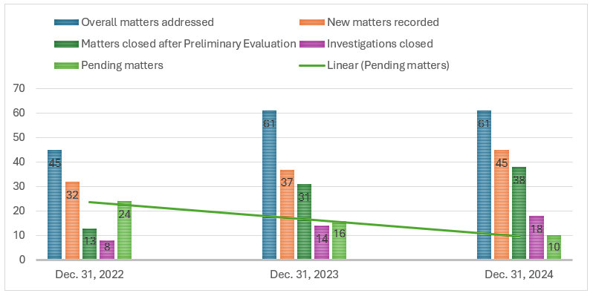

**Table 1 – Categories of Matters Registered in 2022, 2023 and 2024**

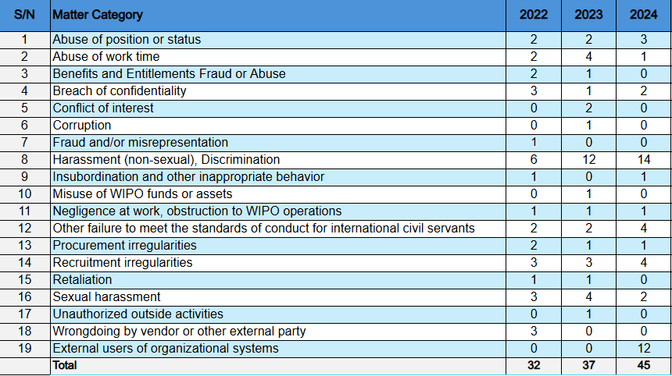

1. During the reporting period, several matters were addressed after preliminary evaluation under Paragraph 80(e) of the Investigation Manual, enabling referrals within WIPO for “more appropriate or less formal” resolution. Although this provision has always existed and aligns with the Staff Regulations and Rules, in prior years, it was not consistently applied. Complaints that could have been resolved by more appropriate or less formal means were often handled by IOD through formal investigative processes.
2. In 2024, 25 out of 38 matters were referred within WIPO for informal resolution after preliminary evaluation. Twelve complaints from external users of the Organization’s business systems were referred to the business units for further clarification to the complainants on relevant provisions and procedures; nine matters were referred to the Human Resources Management Department (HRMD), three matters were referred and addressed through consultative engagement with the appropriate internal justice channels, and one to the office of the Ombudsperson. These trends are illustrated in Chart 2 below.

**Chart 2 – Disposition of Matters Closed after Preliminary Evaluation in 2022, 2023 and 2024**

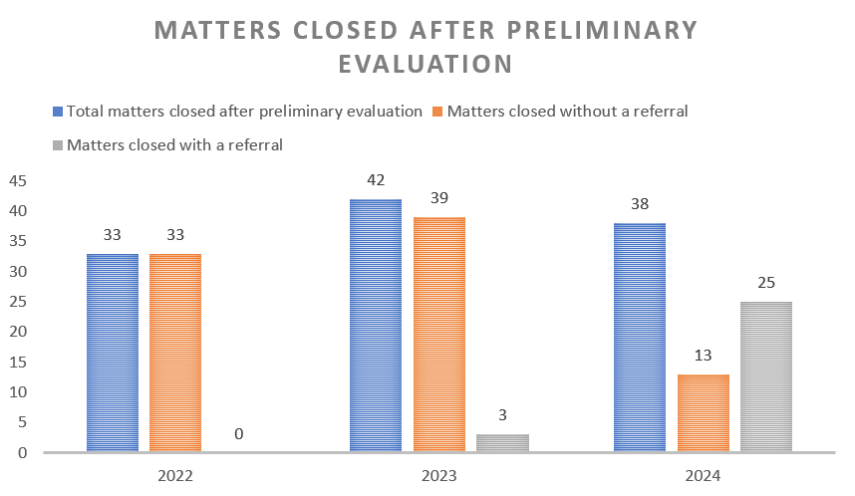

1. Among the 45 matters registered during the reporting period, 10 were referred to the IAOC for its advice in line with the provisions of the IOC.

## Outcome of Investigative activities

1. According to the IOC,[17] the Annual Report shall include a description of the investigative cases found to be substantiated and their disposition. In 2024, IOD found the allegations to be substantiated in eight investigations. The table below summarizes them.

**Table 2 – Substantiated Cases and their Disposition**

| **Type of allegation** | **No. of investigations** | **Nature of Investigation**  **Case Disposition** |
| --- | --- | --- |
| Harassment (non-sexual) | 1 | The investigation concerned alleged harassment (non-sexual) and other misconduct involving a staff member’s supervisor.  Disciplinary proceedings initiated under Chapter X of the WIPO Staff Regulations and Rules. Ongoing. |
| Abuse of Work Time | 5 | * In one case, a staff member engaged in extensive unauthorized absence and failed to comply with the applicable flexible working arrangements.   The case was closed under Chapter X of WIPO Staff Regulations and Rules with imposition of the disciplinary measure of relegation to a lower step within grade, pursuant to Staff Rule 10.1.1(a)(4) with delayed advancement to the next salary step pursuant to Staff Rule 10.1.1(a)(3), for a period of two years. The staff member is not eligible for a step increase during this period.   * In one case, the staff member engaged in unauthorized absence and failed to comply with the applicable flexible working arrangements, although there were mitigating circumstances and action taken.   The case was closed without initiating a procedure under Chapter X of WIPO Staff Regulations and Rules. The staff member was reminded in writing of the need to comply with the regulatory framework.   * In one case, the staff member engaged in unauthorized absence and failed to comply with the applicable flexible working arrangements.   The case was closed without initiating a procedure under Chapter X of WIPO Staff Regulations and Rules. The staff member was reminded in writing to comply with the regulatory framework.   * In one case, the staff member engaged in significant unauthorized absence and failed to comply with the applicable flexible working arrangement.   The case is currently under review by the Director, HRMD.   * In one case, the staff member engaged in unauthorized absence, although WIPO no longer employed the staff member concerned at the time of report issuance.   The case was closed without initiating a procedure under Chapter X of WIPO Staff Regulations and Rules. |
| Entitlements Fraud | 1 | The investigation concerned the submission by a WIPO staff member of fraudulent entitlement claims and the duplication of benefits received by the same staff member from WIPO and an external service provider.  The case was closed under Chapter X of WIPO Staff Regulations and Rules with imposition of the disciplinary measure of dismissal, pursuant to Staff Rule 10.1.1(a)(6)). |
| Wrongdoing by External Party | 1 | The matter concerned the unauthorized gathering and deletion of some of the Organization’s information assets by a contracted external party. The investigation did not identify any significant harm to WIPO’s information assets.  The case is currently under review by the Vendor Sanctions Committee. |

1. None of the above-substantiated allegations were considered to have a significant financial impact on the Organization. Chart 3 shows the number of allegations substantiated and unsubstantiated for investigations concluded in 2022, 2023 and 2024.

**Chart 3 – Allegations Substantiated for Matters Processed in 2022, 2023 and 2024**

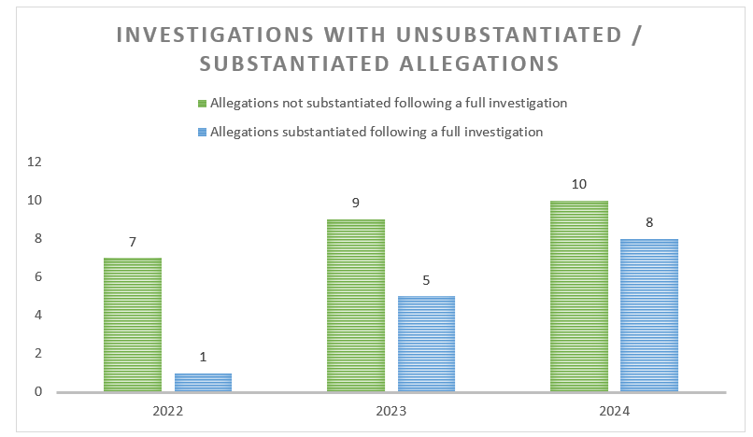

## Management implication reports (MIR)

1. Two MIRs were issued in the reporting period, relating to (i) the processing of internet domain name dispute cases by WIPO’s Arbitration and Mediation Center (AMC) and (ii) WIPO personnel’s unauthorized absence and abuse of teleworking arrangements.
2. WIPO’s AMC acted upon the first matter, and IOD closed the recommendation.
3. On the second matter, IOD recommended that HRMD remind employees of their obligations regarding absences and telework and that supervisors ensure compliance, address irregularities, and escalate issues to management before reporting them to IOD. Both recommendations were implemented in May 2024.

**ADVISORY OVERSIGHT WORK**

1. As part of its advisory services, IOD continued to provide advice as requested on policy documents, evaluations, business processes, and WIPO’s regulatory framework, among other matters. Following the first review of Key Controls in Quarter 1, 2024, IOD engaged in a consultative process with the Office of the Controller, which resulted in refining control descriptions and combining overlapping controls, where relevant, in arriving at rationalized organizational key controls from 76 to 40.
2. In addition, IOD issued a behavioral science advisory report, started in 2023, for the Knowledge Management and General Services Division’s ECCM[18] Microsoft 365 Project (EVAL 2024-06).
3. The behavioral science advisory was intended to identify, design, implement, and measure nudges to support change management and accelerate the adoption by WIPO business units of the new 365 platform and a new way of working.

# INSTANCES WHERE INFORMATION OR ASSISTANCE WAS REFUSED

1. According to paragraph 52(h) of the IOC, the Director, IOD, should report on any instances where IOD’s access to records, personnel, and premises was restricted during the reporting period.
2. IOD reports no instances during the reporting period, as described in paragraph 52(h) of the IOC.

# STATUS OF IMPLEMENTATION OF OVERSIGHT RECOMMENDATIONS

1. The Director General is responsible for ensuring that all recommendations made by the Director, IOD, are responded to promptly, indicating actions taken by Management regarding specific report findings and recommendations[19]. The Director General may discharge this responsibility through Sector Leads and other relevant senior managers responsible for specific operational areas within the Organization[20]. The implementation of all oversight recommendations is subject to regular follow-up by IOD.
2. IOD manages and reports on recommendations using the TeamMate+ system, which enables interactive dialogue with Management to follow up on the effective implementation of open recommendations. As required under paragraph 50 of the IOC, the Director, IOD, submits, every quarter, a report to the Director General, with a copy to the IAOC, regarding the status of the implementation of recommendations, including recommendations made by the External Auditor.
3. As of December 31, 2024, there were 30 open recommendations in the TeamMate+ system — three of high priority, 24 of medium priority, and three of low priority. Of these, 77 per cent (23 recommendations) came from IOD, 20 per cent (six recommendations) were related to recommendations by the External Auditor, and the remaining three per cent (one recommendation) were related to an external review of the Treasury Function,[21] which IOD included in its tracking system to follow up on the implementation of the recommendations therein. Chart 4 below shows the open recommendations by source and priority as of December 31, 2024.

**Chart 4 – Open Recommendation by Source and Priority (30)**

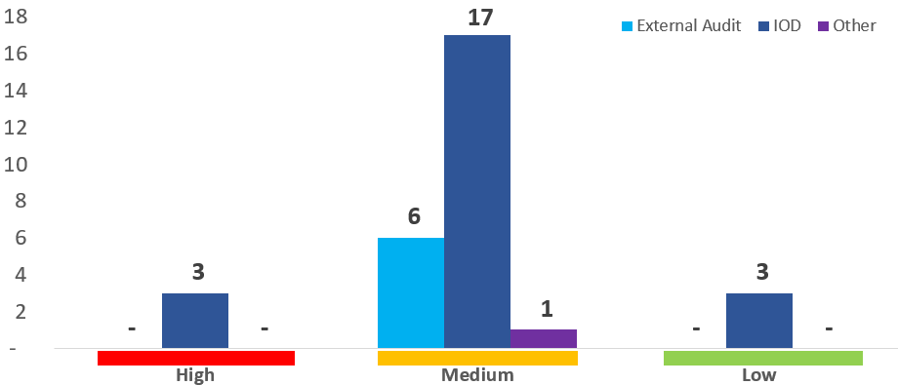

Source: IOD Audit management system TeamMate+, December 2024

1. From January to December 2024, 37 new recommendations were added to the audit management system, including one from a review undertaken by an external party that IOD elevated to monitor the implementation. No recommendations from the External Auditor were issued in 2024. During the same period, 66 recommendations were closed. Table 3 below shows the movement of recommendations by source in 2024.

**Table 3 – Movement of Recommendations from January 1, 2024, to December 31, 2024**

| Source | Open as of January 1, 2024 | Added During the Period | Closed During the Period | Open as of December 31, 2024 |
| --- | --- | --- | --- | --- |
| IOD | 48 | 36 | (61) | 23 |
| External Auditor (EA) | 11 | - | (5) | 6 |
| Other | - | 1 | - | 1 |
| Total | **59** | **37** | **(66)** | **30** |

Source: IOD Audit management system TeamMate+, December 2024

1. The chart below shows the aging of open recommendations based on the initial date the recommendation should have been implemented. Half of the open recommendations (15) were not due, and 47 per cent of recommendations were three to 12 months overdue as of December 31, 2024. Only one recommendation was in the one to three years overdue interval.

**Chart 5 – Aging of Open Oversight Recommendations based on Initial Implementation Date**

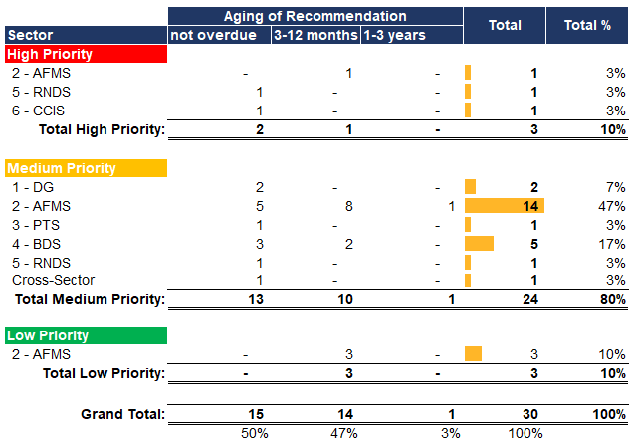

1. As of December 31, 2024, the number of open recommendations by WIPO Sectors and by priority are depicted below:

**Chart 6 – Open Recommendations by Sector and Priority**

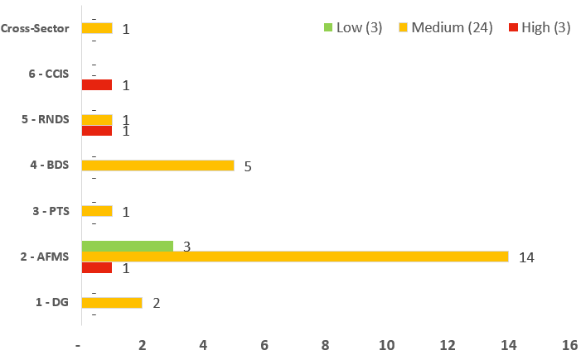

Source: IOD Audit management system TeamMate+, December 2024

1. The majority of open recommendations (77 per cent) related to the Administration, Finance, and Management Sector (AFMS) (60 per cent) and the Brands and Design Sector (BDS) (17 per cent). As of January 1, 2024, AFMS had 31 open recommendations. During the year, 19 new recommendations were issued, and 32 were closed, resulting in 18 open recommendations at the end of 2024.
2. In the case of BDS, there were nine open recommendations at the start of 2024. One recommendation was issued during the year, while five were closed, leaving a total of five open recommendations by year-end.
3. IOD acknowledges the continued support of the IAOC and the Director General and the initiatives taken by the Office of the Controller in engaging with the rest of Management to address open recommendations.

# COOPERATION WITH EXTERNAL OVERSIGHT BODIES

## The Independent Advisory Oversight Committee

1. IOD attended the quarterly IAOC sessions, reporting on the implementation of the 2024 oversight work plan, discussing oversight results and other aspects of the Division’s work and functioning, and seeking the IAOC’s advice as and when required. In the reporting period, the 72nd to 75th IAOC sessions took place. IOD acknowledges the support, guidance, shared experiences, and insights provided by the IAOC throughout 2024.

## The External Auditor

1. IOD engaged with and shared its 2024 oversight work plan with the External Auditor to ensure efficient oversight coverage while avoiding potential duplication of efforts. In addition, all audit and evaluation reports were shared with the External Auditor on a timely basis once completed. Investigation reports were also available on request by the External Auditor.

# OTHER OVERSIGHT WORK

## Cooperation with the ombudsperson and the ethics office

1. During the reporting period, the Director, IOD, met with the Ombudsperson and the Chief Ethics Officer to ensure coordination and complementary support.

## Outreach Activities in the Organization

1. IOD engaged WIPO colleagues throughout the year through assignment kick-off meetings, updates, exit meetings, informal interactions where required, presentations during induction training for new staff, and presentations to Management and Sector Leads as needed. The Director, IOD, attended all quarterly Risk Management Group meetings as an observer while contributing as appropriate to the deliberations from an oversight perspective.
2. In addition, in March 2024, IOD hosted a brown bag session for over 60 WIPO colleagues, attended by the Director General, Deputy and Assistant Directors General, and Senior Managers, to help demystify IOD’s Evaluation Function and gain actionable feedback.

## Networking with other Oversight Functions

1. The IOC includes specific provisions[22] for IOD liaising and cooperating with the internal oversight or similar services of other organizations in the UN system and Multilateral Financial Institutions, as well as representing WIPO in relevant inter-agency meetings.
2. During the reporting period, IOD continued its collaboration, networking and knowledge sharing with other UN system organizations and entities, as well as other relevant non-UN organizations. In particular:

**Table 4 – Professional Events attended by IOD**

| Event (organized by UN and Non-UN organizations) | Date |
| --- | --- |
| UNEG Professional Development Seminar and the Evaluation Practice Exchange for 2024 UNEG EvalWeek, and the UNEG Heads Annual General Meeting (AGM) | January 29 to 31, 2024 |
| Swiss Cybersecurity Days - Shaping Cyber Resilience | February 20 and 21, 2024 |
| Women Investigators Networking in Geneva (WINGS) - International Women’s Day | March 8, 2024 |
| Heads of Internal Audit meeting (Heads of 45 International Organizations). | May 23 and 24, 2024 |
| International Development Agencies Risk Event (Ernst & Young, Geneva) | June 10 to 14, 2024 |
| 16th AGM of the United Nations Representatives of Internal Audit Services (UN-RIAS) and the 53rd RIAS meeting | September 17 to 20, 2024 |
| 24th Annual Conference of International Investigators (CII) and the AGM of United Nations Representatives for Investigation Services (UN-RIS) | November 13 to 15, 2024 |
| Participation in the UN-RIAS Working Group on Innovation | Throughout the year 2024 |
| Knowledge-sharing sessions with the Directors and other staff of Internal Oversight of UN agencies | Throughout the year 2024 |

1. Following the 2024 UNRIAS AGM, the Director, IOD, was selected to be the focal point for UNRIAS to the High-Level Committee on Management of the UN, effective September 2024.

## Training and Continuing Professional Education

1. Continuous learning and development are essential for internal oversight staff to maintain professional certifications and enhance their competence in evolving evaluation, investigation, auditing standards, and leading practices. IOD staff participated in relevant training programs during the reporting period to further develop their skills and expertise. The key training programs included:

**Table 5 – Training Programs Attended by IOD**

| Training | Main topics | Date |
| --- | --- | --- |
| Virtual Fraud Conference of the Association of Certified Fraud Examiners (ACFE) | * Latest trends, tools, and techniques to address anti-fraud challenges | March 13 to 15, 2024 |
| 35th ACFE Annual Global Conference | * Fraud risk assessment * Artificial Intelligence (AI) in investigative processes * Emotional intelligence in investigations * Auditing for internal fraud | June 24 to 28, 2024 |
| UN Investigation training by the UN High Commissioner for Refugees | * Investigation of harassment, abuse of authority, discrimination, retaliation, sexual exploitation and sexual harassment cases. | September 30 to October 4, 2024 |
| Procurement Fraud training course by the CII | * Procurement fraud schemes, * Red flags * Methodologies for investigating procurement fraud | November 8, 2024 |
| Transforming Audit Processes with Generative AI by Wolters Kluwer | * Effective use of AI in internal audit * Cybersecurity – Key risks and controls * Effective governance, trust, and accountability | October 23, 2024 |
| Various online courses by the Information Systems Audit and Control Association (ISACA) | * Introduction to the AI Audit Toolkit * Revolutionize Auditing with AI * Information Technology Internal Audit: Top Areas of High-Impact Focus * Building a Cyber Risk Threat Assessment * Cyber Adversary Modelling: Bridging Gaps in Imperfect Data | November 2024 |

# IOD QUALITY ASSURANCE AND IMPROVEMENT PROGRAM

1. QAIP of IOD is designed to provide reasonable assurance to various stakeholders[23] that oversight activities are performed in conformity with the IOC, the respective professional standards and practices of each function operate effectively, and stakeholders perceive IOD as adding value and continually improving. The areas outlined below are covered in the QAIP.

## Operational Independence of IOD

1. The IOC requires the Director, IOD, to confirm the organizational independence of the internal oversight function and provide information on the scope of the internal oversight activities and the adequacy of resources for the purposes intended. [24]
2. During the reporting period, no instance/activity occurred that could be considered to have jeopardized IOD’s operational independence.  The Director, IOD, formally confirmed this to the IAOC in its 75th session, in addition to the formal and private sessions held in 2024.
3. To develop the 2024 oversight plan, IOD engaged with and obtained input from Sector Leads, the Director General, and Member State representatives, as well as input and advice from the IAOC. However, the final plan was ultimately determined by IOD, considering the feedback received and its risk assessment.
4. The availability and adequacy of resources for IOD were presented and discussed quarterly with the IAOC, including measures to fill the gaps. In 2024, the Administration provided IOD with an additional staff position to address the long-term absence of the Head of the Audit Section and additional financial resources in May 2024 when requested.

## Ongoing Monitoring and Performance Indicators

1. Ongoing monitoring of the performance of oversight activity refers to the day-to-day supervision, review, and measurement of oversight activity built into the IOD Policies, Manuals, and routine procedures.
2. IOD has established Performance Indicators to measure the effectiveness, efficiency, and relevance of oversight activities. These include the average timeline for completing engagements, internal stakeholders’ perception of IOD’s work, and the level of acceptance and relevance of the IOD recommendations. The table below summarizes the results.

**Table 6 - IOD Performance Indicators**

|  |  |  |  |
| --- | --- | --- | --- |
| **Performance Indicator** | **Performance Indicator** | **Results 2023** | **Results 2024** |
| No interference and perceived independence by key stakeholders | No Interference | No Interference was observed during the period | No Interference was observed during the period |
| The average timeline for completing engagements | Internal Audit: 4.5 months | 4.4 months | 3.2 months |
| Evaluations: 6 months  -Completion of 2022 and 2023 reports  -Completion of 5 pre-evaluation reviews and 1 advisory in 2024 | 5.3 months  N/A | 13.4 months  4 months |
| Investigations: 6 months  -Closure of 18 matters brought forward from 2022 and 2023  -Closure of preliminary evaluations | 8.7 months  4.0 months | 11.6 months  1.9 months |
| % of internal stakeholders who perceive that IOD recommendations are SMART | 80% | 88% of managers perceived that IOD recommendations were SMART | 84% of managers perceived that IOD recommendations were SMART |
| % of internal stakeholders who perceive that Oversight work is Relevant | 80% | 79% of respondents perceived that Oversight work was relevant | 87% of respondents perceived that Oversight work was relevant |
| No. of oversight recommendations accepted | 90% | 100% of IOD recommendations accepted | 100% of IOD recommendations accepted |

1. As of January 2024, there were 18 ongoing investigations carried forward from 2022 and 2023.
2. The delay in completing investigations specifically related to 2022 and 2023 was due to multiple factors, including (i) there was only one full-time investigation staff member from April through to December 2024 as a result of unfilled vacancies and the time lag in filling the posts in 2024; (ii) a steady increase in the number of new complaints required re-prioritization in 2024 to address emerging matters; (iii) the complexity of some matters, including inputs from external parties with time lags therein leading to three matters taking over 10 months ; (iv) turnaround time (particularly for investigations outsourced to external investigative firms that faced unanticipated constraints) leading to two matters taking over 10 months; (v) unavailability of relevant parties to the investigation which led to two matters being on hold for 11 months and/or lack of effective cooperation and therefore delay in the conclusion of the matters.
3. As indicated in paragraph 57 above, there was no evaluation staff from February to December 2024. The draft reports prepared before the staff absences or sick leave had to be

re-assigned and addressed, among other competing interests. There was a need for various rounds of review and updates of the evaluation reports, additional data verification to ensure accuracy and reliability, and new insights and stakeholders’ feedback. As indicated in paragraph 29 above, the evaluation report included in the 2022 work plan, which only commenced in January 2023, was issued in May 2024. In addition, after various revisions, three reports related to the 2023 work plan, as indicated in paragraphs 34 to 44 above, were issued in April, November, and December 2024.

1. However, all audits, investigation matters registered in the reporting period, and pre-evaluation reviews undertaken during the reporting period, as per the 2024 oversight work plan, were completed within the established timeframes, demonstrating the commitment to accountability and compliance.
2. Indicators continue to show high acceptance of the relevance of IOD’s work and the pertinence of its recommendations.

## Satisfaction Survey

1. After each engagement, IOD continued to seek feedback from colleagues of audited and evaluated organizational units through client satisfaction surveys. By the end of 2024, the consolidated analysis of survey results indicated a satisfaction rate of 87 per cent[25].
2. The results of surveys conducted at least one year after the completion of the engagement and when at least 70 per cent of recommendations have been implemented indicated an average satisfaction rate of 85 per cent.[26] This survey assesses the impact and outcome of implemented recommendations on the program. Additional comments sent by the audited/evaluated units through the surveys help IOD identify opportunities for improvement and corrective actions.

## Periodic Internal and External Assessments

1. As per paragraph 30(e) of the IOC, each function of IOD undertakes periodic self-assessments and external reviews (every five years) to determine whether the functions of IOD carry out their duties effectively and efficiently and in conformance with applicable professional standards. The results of the self-assessments and external assessments are communicated to IAOC at the next meeting following the assessment report date.
2. The Evaluation Section underwent a Peer Review by UNEG in the last quarter of 2024. The review aimed to provide insight to enhance the contribution of WIPO’s evaluation function to organizational decision-making, learning, and accountability. The Peer Review covered evaluation activities carried out from 2019 through September 2024, focusing primarily on the centralized evaluation function within IOD.
3. The overall conclusion of the Peer Review was that the evaluation function was currently underperforming and falling short of its full potential despite significant efforts in the past to strengthen the function and evaluation culture. The report was issued on January 24, 2025.
4. The report included recommendations on reviewing and updating the Evaluation Policy and Manual, improving the quality assurance system for evaluation reports, addressing the staff gaps via recruitment, and continuing support from senior Management and IOD to improve the evaluation function and organizational evaluation culture further.
5. Action plans have been developed to address in 2025 each of the recommendations made and agreed upon.

# INTERNAL OVERSIGHT RESOURCES

## Budget and Staffing

1. To discharge its mandate, the 2024 budget of IOD amounted to 3.16[27] million Swiss francs, which represents 0.66 per cent of WIPO’s budget (479.2 million Swiss francs)[28] for the same period (IOD - 2023: 0.61per cent, WIPO - Annual budget: 483.8 million Swiss francs). In 2024, the expenditure was 2.47 million Swiss francs (2023: 2.97 million).
2. The budget utilization in 2024 on personnel stood at 88 per cent (2023: 102 per cent). This was due to staff vacancies not being filled in the year for the Head of Investigation (from April 2024) and Head of Evaluation (from September 2024) and temporary staff in the Investigation Section (filled in September 2024) and Evaluation Section. For the Investigation Section, external individual investigators and an investigative firm were utilized during the year to address some investigative matters.
3. Non-personnel budget utilization in 2024 was 47 per cent (2023: 90 per cent) and was attributed to additional funding requested and obtained in May 2024 in anticipation of an increased investigative caseload and the need to hire external consultants to assist with these and anticipated evaluation assignments.
4. As indicated above, no full-scale evaluations were conducted in 2024, while the number and nature of matters filed for investigation did not result in additional significant consultancies.
5. Chart 7 below shows the budget and expenditure analysis, position grade, and gender mix of IOD personnel in 2024.

**Chart 7 – 2024 IOD Budget/Expenditures**[29] **and Personnel**

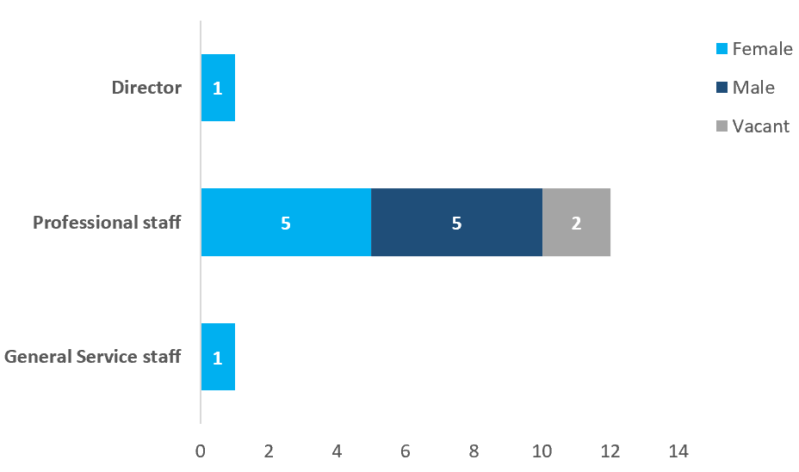

Source: WIPO WePerform

# 2025 and beyond

1. The IOC, approved by the WIPO General Assembly at the Sixty-Fifth Series of Meetings held from July 9 to 17, 2024, was published and came into force on January 1, 2025.
2. The revised Audit Policy and Manual were published and came into force on January 20, 2025.
3. The revised Investigation Policy and Manual were published and came into force on January 28, 2025, and January 29, 2025, respectively.
4. The revision of the Evaluation Policy and Manual is scheduled for completion by December 31, 2025.
5. Fourteen open recommendations were implemented between December 31, 2024, and February 28, 2025, leaving 16 recommendations open (six of which are from the External Auditor) as of the end of February 2025.
6. Two pending investigations from 2022 and 2023, as of December 31, 2024, were closed in early January 2025, bringing to a close all pending matters from 2022 and 2023.
7. The Internal Audit Section completed a periodic self-assessment, with a conclusion of “generally conforms.” The key area for further improvement was the full documentation retained in engagement files. This will be addressed in 2025.
8. The Investigation Section completed a periodic self-assessment in March 2025. The key improvement area is the turnaround time of investigations, which will be addressed in 2025.
9. The Internal Audit and Investigation Sections are scheduled for external reviews in 2025, following the last reviews in October and November 2020, respectively.
10. IOD is on track to implement the recommendation made by the External Auditor in their report for the financial year 2020,[30] to provide an annual opinion on WIPO’s governance, risk management, and control environment. This recommendation is expected to be fully implemented from the year ending December 31, 2025.
11. Recruitment activities for vacancies in the Investigation and Evaluation Sections are on course with a view to completion within 2025.

# CONCLUSION

1. IOD wishes to thank the IAOC, Director General, Sector Leads, and WIPO personnel for their continuous support, enabling the Division to carry out its mandate in 2024 successfully.
2. IOD looks forward to working closely with the IAOC, the Director General, Sector Leads, and WIPO personnel to achieve the Organization’s objectives and key results as set out in the MTSP 2022-2026 whilst continuing to strengthen its contribution to governance, risk management, internal control processes,decision-making and oversight, reputation and credibility with its stakeholders, and ability to serve the public interest.

[Annex follows]

**ANNEX - List of IOD Documents and Reports**

| **Oversight Charter, Policies, and Manuals updated in 2024[31]** | **Ref.** | **Entry into Force** |
| --- | --- | --- |
| Internal Oversight Charter | WO/PBC/GA/37/5 | January 1, 2025 |
| Internal Audit Policy | IOD/IAP/2025 | January 20, 2025 |
| Internal Audit Manual | IOD/IAM/2025 | January 20, 2025 |
| Investigation Policy | IOD/IP/2025/1 | January 28, 2025 |
| Investigation Manual | IOD/IM/2025/1 | January 29, 2025 |
| **IOD reports issued from** **January 1, 2024, to December 31, 2024** | **Ref.** | **Report Issuance Date** |
| **Audit Engagements** | | |
| Audit of Cloud Management | IA 2023-02 | January 31, 2024 |
| Audit of Cybersecurity Management | IA 2024-02 | May 15, 2024 |
| Review of Key Controls Design and Operating Effectiveness – Quarter 1 Testing Results | IA 2024-03 | May 17, 2024 |
| Audit of the PCT Translation Division | IA 2024-04 | December 19, 2024 |
| Internal Audit of the WIPO Nigeria Office | IA 2024-05 | December 19, 2024 |
| **Review Engagements** | | |
| Validation of the After-Service Health Insurance (ASHI) | IA 2024-01 | April 25, 2024 |
| Validation of WIPO Performance Report (WPR) | VALID 2024-01 | May 6, 2024 |
| **Evaluation Engagements** | | |
| Evaluation of Chobe Baskets Project | EVAL 2023-02 (Report I) | April 19, 2024 |
| The Combined Audit and Evaluation of The Patent Cooperation Treaty (PCT) Operations and Customer Relations – Part II - Verification of the PCT Culture of Customer Service | EVAL 2022-05 | May 15, 2024 |
| Pre-evaluation Assessment of WIPO Connect | EVAL 2024-01 | July 12, 2024 |
| Pre-evaluation Assessment of Madrid Fellowship Program | EVAL 2024-02 | July 30, 2024 |
| Pre-evaluation Assessment of WIPO Academy Academic Institutions and Executive Program | EVAL 2024-03 | August 28, 2024 |
| Pre-evaluation Assessment of WIPO Academy IP eLearning Section | EVAL 2024-04 | August 29, 2024 |
| Pre-evaluation Assessment of the WIPO Fellowship Programs | EVAL 2024-05 | September 16, 2024 |
| Behavioral Science Advisory Assignment for the Enterprise Content Management (ECM) Collaboration Project-2nd part | EVAL 2024-06 | September 16, 2024 |
| Evaluation of Indigenous and Local Community Women Entrepreneurship Program (WEP) | EVAL 2023-02 (Report II) | November 20, 2024 |
| Evaluation of the Project on Increasing the Role of Women in Innovation and Entrepreneurship | EVAL 2023-02 (Report III) | December 2, 2024 |
| **Management Implication Reports** | | |
| Management Implication Report on Internet Domain Name Dispute Case Processing in WIPO’s Arbitration and Mediation Center (AMC) | MIR 2023-19 | February 12, 2024 |
| Management Implication Report on WIPO personnel unauthorized absence and abuse of teleworking | MIR 2022-20 | April 4, 2024 |

[End of Annex and of document]

1. IOC paragraph 51.
2. The term Advisory is used when IOD supports the client by providing advice and making comments but does not take the lead in managing the activity or producing a formal deliverable.
3. Evaluation of the Division for Latin America and the Caribbean
4. Audit and Evaluation of the Patent Cooperation Treaty (PCT) Operations and Customer Relations. Part I: Results of the Audit of the PCT Operations (IA 2022-05)
5. Learning from the Implementation of WIPO Initiatives aimed at Empowering Women Entrepreneurs (EVAL 2022-03), May 17, 2023.
6. SOC 2 is a security framework that specifies how organizations should protect customer data from unauthorized access, security incidents, and other vulnerabilities. The framework is developed by The American Institute of Certified Public Accountants.
7. Globally recognized standard for quality management. It helps organizations of all sizes and sectors to improve their performance, meet customer expectations and demonstrate their commitment to quality. Its requirements define how to establish, implement, maintain, and continually improve a quality management system.
8. ISO 27001 is an international standard for information security management systems (ISMS). It provides a framework for organizations to establish, implement, maintain, and continually improve an ISMS, which is a systematic approach to managing sensitive company information, ensuring its confidentiality, integrity, and availability.
9. EARM 2021-01 Recommendation 3: WIPO should accelerate the timetable for IOD to provide an annual opinion over WIPO’s governance, risk management, and control environment to provide Member States with additional assurance over these key areas of oversight and support the Director General in preparing his Statement on Internal Control.
10. The review of the IT Security of Core Applications used by the PCT Translation Division was limited to understanding the IT security environment around applications and analyzing available external and internal assurance. In addition, IOD followed up on the status of vulnerabilities identified in the Penetration Testing exercise undertaken by an external vendor in May 2024.
11. Limited to review of relevant KPIs.
12. Document WO/PBC/37/8, May 3, 2024.
13. Tracer Study Report evaluates university programs that have achieved a five-year milestone, aiming to assess their relevance, effectiveness, and impact.
14. Thirty-five matters were registered in 2024, while two matters were carried over from 2023 and one from 2022.
15. Four investigations were concluded for matters registered in 2022, and 14 were concluded for matters registered in 2023.
16. Eight matters were registered in 2024, one in 2023, and one in 2022. The 2022 and 2023 matters were subsequently closed in January 2025.
17. IOC paragraph 52(c).
18. The ECCM introduces a central enterprise repository to store documents. The project aims to continue and accelerate WIPO’s digital transformation, focusing on content management and collaboration capabilities.
19. IOC paragraph 49.
20. OI 16/2010, paragraph 7.
21. One recommendation “for tracking” related to the peer review performed by the Reserve Advisory and Management Partnership (RAMP) of the World Bank in 2023. RAMP is a program developed within the World Bank Treasury that delivers advisory services, hosts executive training, and provides asset management services. Established in 2001, the Partnership serves over 70 members, including mostly central banks as well as international financial institutions, pension funds, sovereign wealth funds and UN organizations.
22. IOC paragraph 30(f).
23. The main stakeholders include WIPO Management, the External Auditor, the Director General, the IAOC, Member States and the public at large.
24. IOC paragraph 52(i).
25. During the reporting period, IOD received responses to ten surveys for engagements conducted in 2024.
26. During the reporting period, IOD received responses to eight surveys on engagements conducted between 2021 and 2023.
27. Source: WIPO WePerform: Budget after Transfers figures in Swiss francs.
28. [WO/PBC/36/8](https://www.wipo.int/export/sites/www/about-wipo/en/budget/pdf/budget-2024-2025.pdf), Annex VIIII, Annual budget 2024-2025
29. Source: WIPO WePerform; figures in Swiss francs.
30. (WO/PBC/33/5) Report of the External Auditor for the financial year 2020 to the 62nd Series of Meetings of the Assemblies of the Member States of WIPO (also known as the “long form report”).
31. Updates were made in consultation with the IAOC, Member States, and WIPO internal stakeholders.