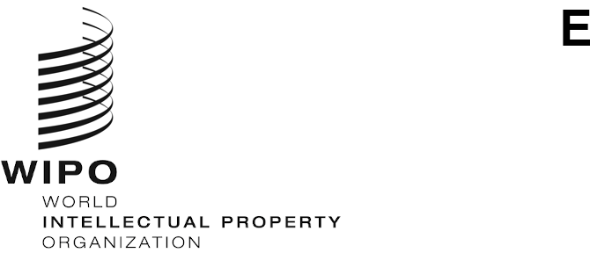

WIPO/GRTKF/IC/49/8

ORIGINAL: russian

DATE:  November 14, 2024

**Intergovernmental Committee on Intellectual Property and Genetic Resources, Traditional Knowledge and Folklore**

**Forty-Ninth Session**

**Geneva, December 2 to 6, 2024**

Proposal for Updating the List of Non­Governmental Organizations admitted as *Ad Hoc* Observers to the IGC

*Document submitted by the Delegation of the Russian Federation*

1. On November 1, 2024, the International Bureau of the World Intellectual Property Organization (WIPO) received a request from the Permanent Mission of the Russian Federation to the UN Office and Other International Organizations in Geneva to submit a proposal to invite the Intergovernmental Committee on Intellectual Property and Genetic Resources, Traditional Knowledge and Folklore (IGC) to continue updating the list of non­governmental organizations admitted as *ad hoc* observers to the IGC, for consideration by the Forty-Ninth Session of the IGC under agenda item 3 “Accreditation of Certain Organizations”.
2. Pursuant to the request above, the Annex to this document contains the proposal   
   referred to.
3. *The Committee is invited to consider the proposal in the Annex to this document.*

[Annex follows]

**Proposal by the Russian Federation**

At the Forty-Fifth Session of the Intergovernmental Committee on Intellectual Property, Genetic Resources, Traditional Knowledge and Folklore (IGC), which was held from December 5 to 9, 2022, the Secretariat submitted document WIPO/GRTKF/IC/45/2 on the growing number of non-governmental organizations (NGOs) admitted as *ad hoc* observers to the Committee, and the difficulties associated with that growth.

In paragraph 4 of the document, the Secretariat noted: “The steep rise in NGO observers accredited to the IGC raises the question of whether the list accurately reflects the actual number of organizations still in existence and/or still interested in participating in the negotiations of the IGC.”

At the end of the session, the Committee took note of the document and agreed that the list of NGOs admitted as *ad hoc* observers to the Committee should be updated.

At its Forty-Seventh Session, held from June 5 to 9, 2023, the Secretariat reported on the work done thus far, noting that it had taken several steps, as specified in document WIPO/GRTKF/IC/45/2 (para. 7), to identify the NGOs that were defunct or no longer interested in participating in the work of the Committee (document WIPO/GRTKF/IC/47/20).

According to the latter document, the Secretariat distributed a survey through Notes C. 9145 in March and April 2023, asking all NGOs admitted as *ad hoc* observers to the Committee that had not participated in the work of the Committee between its thirty-fifth and forty-fourth sessions to confirm that they remained interested in that work and wished to retain their status as *ad hoc* observers.

Judging by the documents submitted and comments made by the Secretariat, it would appear that, aside from sending individual observers the survey and request to confirm their interest in attending the Committee’s meetings, no substantial work has been done to update the list of accredited observers, including by identifying those NGOs that are now defunct.

With a view to ensuring that representatives of Indigenous Peoples and Local Communities are duly able to take part in the work of the Committee, and to carrying out the task, set forth in document WIPO/GRTKF/IC/45/2, of identifying NGOs accredited as *ad hoc* observers that are now either defunct or no longer interested in participating in the Committee’s sessions, we invite the Committee to continue its work in that regard and to instruct the Secretariat to update the list of accredited observers, removing NGOs that are *de jure* or *de facto* defunct, and to report on progress at the Committee’s Fiftieth Session.

To that end, it is proposed that observers be asked, in addition to confirming their interest in attending meetings of the Committee, to submit official (constituent) documents confirming their existence in the jurisdiction of a Member State (or Member States) of the World Intellectual Property Organization (WIPO) in which they operate. That work should be conducted with regard to all observers accredited to the Committee.

[End of Annex and of document]